PAWFORMANCE TRACKER
Project Proposal
Mobile Application Development
(E01)

Prepared By:
Adora Decena
November 12, 2025

- Introduction

This proposal is an outline of the design and development plan for Pawformance Tracker, a mobile app made for dog owners who want an easy way to track their dog’s walking routine. A dog-friendly version of the fitness apps like Strava. Using real-time GPS tracking and a built-in timer, it will help you monitor each walk from start to finish.

The app will be designed using both stateless and stateful widgets, navigation and routing, gesture handling, state management, and full unit and widget testing. Additionally, it will bring in two bonus features: geolocation access and local storage.

Also, this proposal will outline a clear app structure, organized folders, and how third-party packages will be used to support the build.

- Purpose

Most fitness apps are designed for humans, not dogs. So, if you want a simple way to log how far or how long your dog walked, this app is for you.

With this app, you can:

- Log how long each walk lasts
- Track distance with real-time GPS
- View your full walk history
- *Optional personal notes

- Functionality / Features

Start Walk Tracking
- Tap to Start Walk
- Timer begins counting the duration
- GPS begins capturing coordinates

Stop Walk Tracking
- Tap to Stop Walk
- Timer stops
- GPS stops
- Calculate distance using GPS points
Walk Summary Screen
- Display:
  - Total duration
  - Total distance
  - Walk date/time
  - *Optional – input notes
- User can Save / Discard Walk
Walk History
- Saved Walks list stored locally
  - Date of walk
  - Duration
  - Distance
- Tap to view details
- Swipe to delete
Walk Detail Screen
- Show full walk stats
  - Duration
  - Distance
  - Note
  - Date & Time
Additional features:
- Geolocation Access
  - Using geolocator package
  - For real-time latitude/longitude updates
- Local Storage
  - Shared_preferences
  - Stores all walk activities

- Third-Party Packages
- Geolocator (gps)
- Provider
- shared_preferences,
- intl (date/time)
- flutter_test

- Architecture
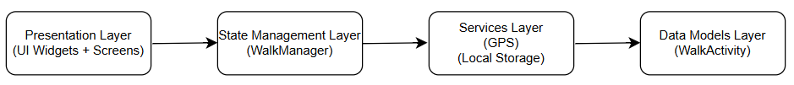
- Directory structure (*optional - walk_detail_screen.dart)
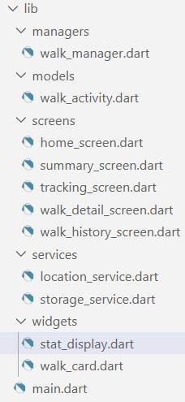
- Wireframe Sketches
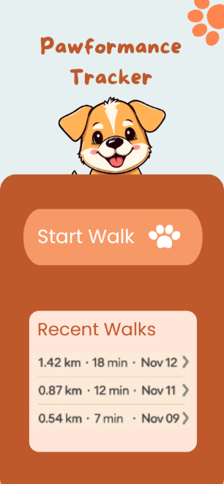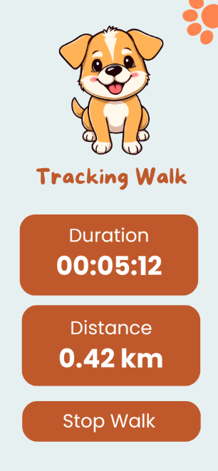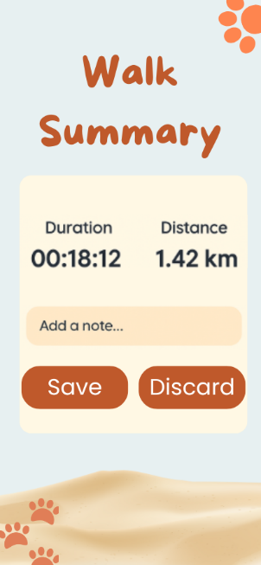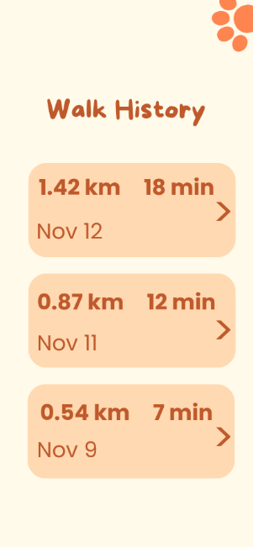

*Optional
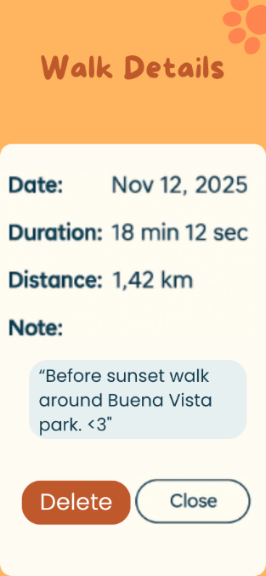

- Development Timeline (3-week plan)
  - Week 1:
Creation of flutter project, Set folder structure, Start to build screens (UI), Implement navigation
  - Week 2:
Implement GPS, Distance calculations, Timer for live tracking, Build WalkManager with Provider, Build Summary screen and Save/Discard workflow, Implement local storage
  - Week 3:
Prepare Unit tests, Test app, Polish UI / fix bugs

- Testing
The testing plan for this project will include unit and widget testing. Unit tests will validate distance calculations, WalkManager state updates and JSON saving/loading. Widget tests will check UI behavior, which includes navigation between screens and correct rendering of walk history list.

